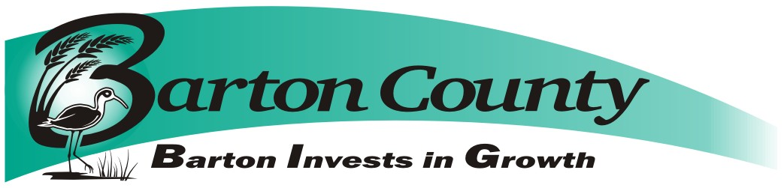Barton County Solid Waste Department - 1400 Main, Room 108 - Great Bend, KS 67530
Landfill (620) 793-1898 Fax (620) 793-1899

May 17, 2018

Request for Proposals (RFP)
For: Improvements to North Maintenance Shop
Submission deadline: 2:00 pm Wednesday, June 6, 2018
Deadline for final submission of questions: 2:00 pm Friday, June 1, 2018
No interpretation of the meaning of the Bid Documents (drawings, specifications, et. al.) will be made to any bidder. Questions may be submitted, in written form, to:

Phil Hathcock
Solid Waste Manager
350 NE 30 Road
Great Bend KS, 67530
(620)793-1899
Fax (620)793-1899
or emailed to solidwaste@bartoncounty.org

Questions will be answered within 2 business days via email with a return reply acknowledging receipt of the email requested. Questions and answers will be shared with all bidders.

Introduction
Barton County Landfill, (Owner) invites proposals for the installation of (1) 40’ X 60’ steel building at 350 NE 30 Road, Great Bend, Kansas, 67530.

Submission Procedure
Proposals conforming to the requirements set out below must be received by Barton County via US mail or courier to Barton County Clerk, 1400 Main Street, Rm 202, Great Bend KS 67530 no later than the deadline given above. Proposals must state that they are valid for a period of at least ninety (90) days from the closing deadline. Physical proposals must be submitted in sealed opaque envelope and marked, [Landfill HHW Building]. Barton County reserves the right to waive irregularities and to reject any or all bids. This project will be sales tax exempt.

Barton County may consider informal any bid not prepared and/or not submitted in accordance with the provisions hereof and may waive any informalities or reject any and all bids. Any bid may be withdrawn prior to the above scheduled time for the opening of bids or authorized postponement thereof. Any bid received after the time and date specified shall not be considered. Bids submitted after the closing date and time will be returned to the bidder unopened. No bidder may withdraw a bid within sixty (60) days after the actual date of the opening thereof.

Modification of Bids
Modifications to bids already submitted will be allowed if submitted in writing prior to the time fixed in the Request for Proposals. Modifications shall be submitted as such and shall not reveal the total amount of either the original or revised bids.

Opening, Evaluation and Contracting
Proposals may be opened by Barton County at any time after the submission deadline. All proposals satisfying the requirements of this Request for Proposals will be evaluated to establish which of the offerors best fulfills the needs of Barton County and this project. Barton County anticipates entering into a contract with this/these offeror(s) to execute the proposed work. This Request for Proposals, however, does not commit Barton County to award a contract, to pay any costs incurred in the preparation of a proposal or to contract for the goods and/or services offered. Barton County reserves the right to accept or reject any or all proposals received as a result of this request, or to cancel this Request for Proposals, if it is in the best interests of Barton County to do so. The successful vendor will be required to sign a form provided by the County’s insurance carrier that the vendor is an independent contractor and not an employee of Barton County. The decision of Barton County shall be final.

Project Completion
The Project is to be completed on or before August 30, 2018. In the event that the project is not completed on or before August 30, 2018, Barton County reserves the right to terminate the contract and hire others to complete the project.
.
Proposal Contents
Proposals, together with letters of transmittal, should include the bidder’s description of the work that would be performed and the following information:
• The name of the person in your firm who would be the official contact person for any contractual relationship.
• A schedule for the work, including the range of start dates to which your firm is prepared to commit and anticipated completion dates.
• Proof of insurance.
• Email address of contact person.
• List of subcontractors the bidder intends to use.
• Proof of insurance of any subcontractor the bidder intends to use.

PROPOSED SCOPE OF WORK:

Barton County Landfill, (Owner) invites proposals for the installation of (1) 40’ X 60’ steel building at 350 NE 30 Road, Great Bend, Kansas, 67530. The building will encompass an existing prefab concrete structure that is already onsite. When complete, the prefab structure will be inside the northwest corner of the new building. All other structures and obstructions will be removed by County personnel prior to the start of construction.

Barton County will be responsible for any and all electrical, heating and/or plumbing in the proposed building.

Barton County personnel will assist in site preparation at the direction of the contractor.

Installation of Concrete Floor:

Install concrete floor appropriate for a 40’ X 60’ building to the following specifications:

- Slab size appropriate for 40’ x 60’ building
- 6” thick reinforced concrete AE 4000 psi.
- Slab will be power troweled finished.
- Contraction joints shall not be spaced greater than 15 feet X 15 feet.

Steel Building – Minimum Specifications

- Steel Truss Design
- 16’ tall eave height
- Ground snow load: 20 lbs per sq. ft.
- Wind Load:>100 mph
- Roof Pitch 3:12
- Galvalume Roof (26 gauge)
- Steel siding to match existing scale house, 26 gauge (color and trim)

Installation of Overhead Doors:

Install (2) overhead doors with the following specifications:
1) Door size shall be at least 10’ wide and 12’ tall
2) Doors shall be 2” thick, Urethane foam insulated (R-17) with steel on both sides, white both sides
3) 100 mph wind load rating
4) Reverse angle track-15”radius –standard lift with torsion springs
5) Weather stripping on head and jambs

Installation of Exterior Walk Door:

Frame and install (2) exterior walk door in Building with the following specifications:

- One 3070 commercial insulated walk door (18 gauge), solid, white. Lever lock set, dead bolt, hinges, threshold. (complete)
- Framing material shall be 12 gauge or heavier.

For each of these elements, the Contractor must perform “The Work” as listed in this document. Barton County will be operating as Project Manager and Coordinator for the work. Bidders are encouraged to visit Barton County Landfill and inspect the project.

Engineering/Permitting
The Contractor is solely responsible to apply, pay for and obtain all permits if they are required for this project including not limited to: Building and Trade permits for hauling equipment and any and all other City, State and Federal permits required for the execution of this contract.

Warranty
The Contractor must warranty all products, work and services provided for a period of one year after the punch list is completed. The Contractor must turn over all equipment warranties to Barton County.

Other Work
If a bidder has identified a scope of work not listed in either the section called “The Work,” nor in “Proposed Scope of Work” that the bidder feels is required to complete the project, then the bidder should assume that scope falls within the bidder’s responsibilities. Any work identified as such must be listed and described separately in the Request for Proposals response and detailed estimates of costs provided.

