2019 BUDGET MESSAGE

It is my privilege to present the proposed 2019 operating budget to the Barton County Commission. This budget represents an organizational blueprint to maintain delivery of quality public services at an affordable cost to the taxpayer while maintaining a near constant mill levy. The Commissioners once again faced many challenges this year as they worked to balance the budget. Most prevalently, the Commission had to determine a manner in which to fund increasing uncontrolled costs which included the employer portion of health insurance, general liability insurance, and KPERS retirement. Fortunately, the 2019 budget includes a valuation increase of $9,803,841, which equates to an increase of budget authority of approximately $382,000.

As stated earlier, the 2019 budget includes mandatory costs that the county cannot control such as an $45,000 increase in health insurance costs, $100,000 increase in the employer portion of KPERS retirement costs, $32,000 increase in general liability insurance and a $29,000 increase in costs relating to the detention center. Some other costs that were included in the budget were a $53,000 increase in the local effort for the Health department, a 45 cent raise for county employees, $80,000 health insurance subsidy, and $19,000 for cybersecurity programs.

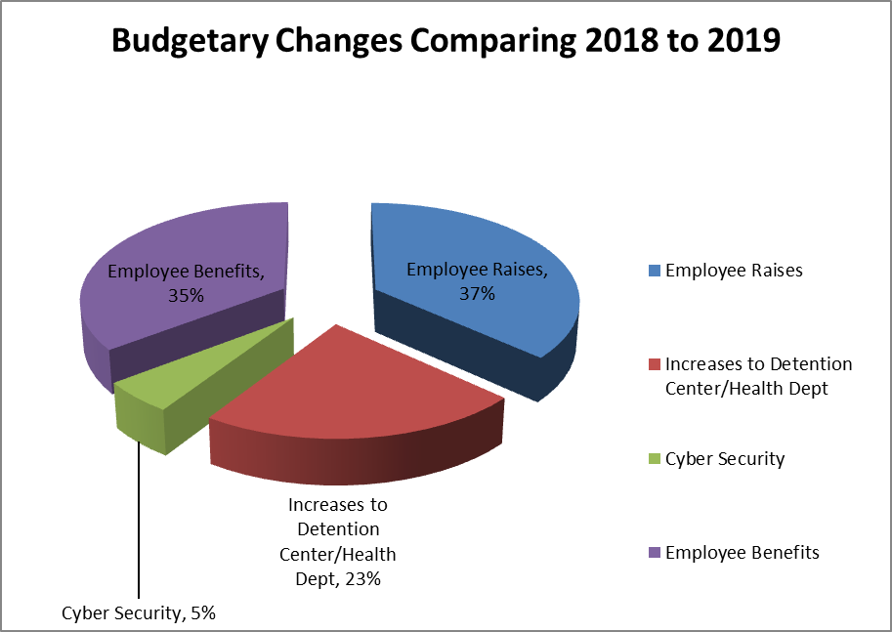

Budget Details

The proposed budget supports a slightly lower mill levy for the 2019 year due to a cap in expenditures by the current legislative tax lid. Lowering the mill levy further would cut expenditures into the foreseeable future or until the state lifts the lid. There were other requests to increase expenditures that were not funded. Supported agencies as well as all county departments were held at the 2018 level excepting the increases already mentioned.

You will see most notably, the increase for medication and expenses in the detention center, and an increase in the general liability insurance cost. Also the County Clerk- election line was reduced as it is an off year for elections.

The following chart shows anticipated revenue for all levied funds, note that ad valorem tax is only 59% of the county’s revenue.

Levied Funds
Anticipated Revenues - 2018

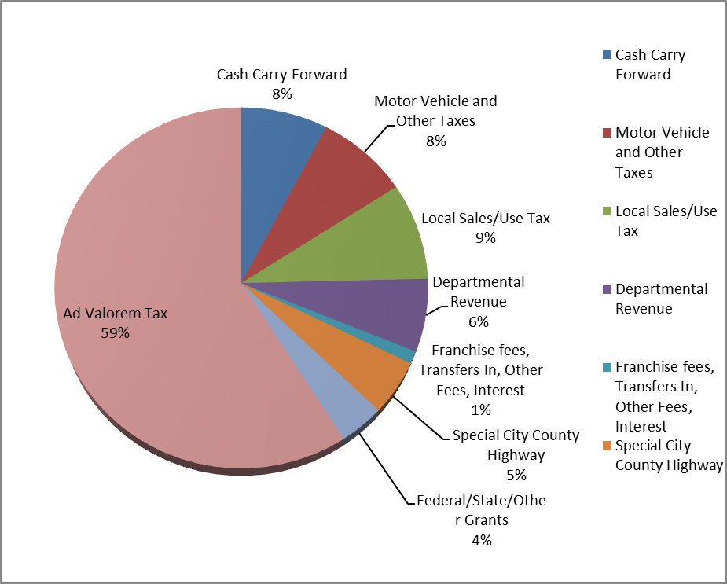

This chart shows a breakdown of planned expenditures for all levied funds in 2019:

Levied Funds
Planned Expenditures - 2019

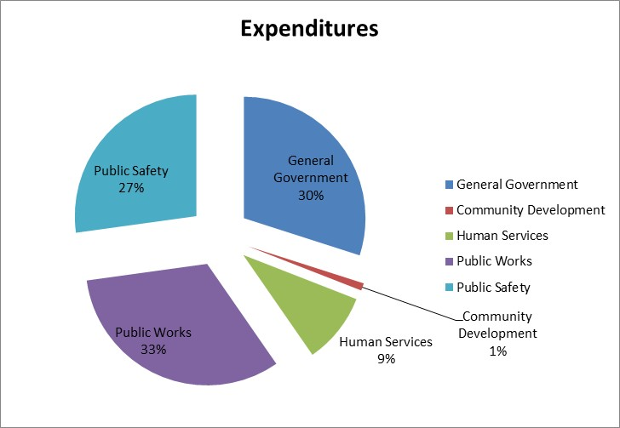

The Notice of Budget Hearing that was published July 20th provides an overview of the county budget. This Notice details the actual expenses for 2017, adopted expenses for 2018, and the proposed budget for 2019. The most significant number in the Notice of Budget Hearing is the estimated mill levy of 43.592 which is slightly lower than the the 2017 mill levy that funded the 2018 budget. This again is a function of the tax lid, lowering the mill levy further would limit expenditures for the foreseeable future, or until the legislators modify the tax lid. The total mill levy, 43.592, generates $11,610,008 in property tax and is equivalent to $266,333 per mill.

In summary, the 2019 budget is funded by a slightly lower mill levy, which is possible due to increased valuations.

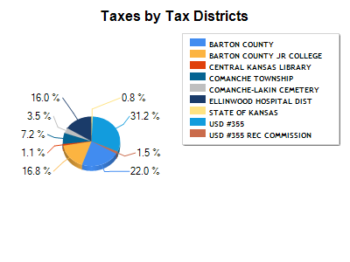
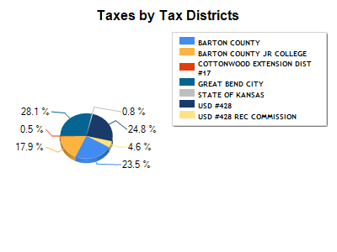
This slide indicates how your tax dollars are distributed throughout the county. As you can see from the graph, depending on where you live, only 20-26% of your tax dollars support county government.

SUMMARY

In summary, the 2019 budget is funded by maintaining a constant mill levy, which is possible due to increased valuations.

After the budget was prepared, the administration office received a verbal notification from the County Attorney of the costs that might be associated with the recent double homicide that occurred in Barton County. As it would be premature to levy tax dollars for costs related to this case, this budget only includes funds that are normally budgeted for special cases.

The County presently has adequate cash reserves in the Capital Improvement and Equipment Replacement Accounts. By not depleting reserves, the county remains fiscally sound and is in the position to sustain a constant mill levy while providing quality services.

I want to thank the Commissioners for their hard work on the budget as well as the elected officials, department heads, and supported agency heads for their assistance. I also want to recognize Matt Patzner, Finance Officer his countless hours putting together the budget document.

