2020 BUDGET MESSAGE

Thank you for the opportunity to present the proposed 2020 operating budget to the Barton County Commission. This budget, as presented, represents an effort to maintain delivery of quality public services at an affordable cost to the taxpayer while maintaining a close to constant mill levy. Each year the Commissioners are faced with many increasing budget requests as well as increasing uncontrolled costs which present challenges as they work to balance the budget. The 2020 budget includes a valuation increase of $11,578,084, largely from The Overland Pass pipeline on which the tax-exempt status termed, which equates to an increase of budget authority of approximately $479,412.

Specifically, 2020 budget includes mandatory costs that the county cannot control such as an $114,000 increase in health insurance costs, $21,700 increase in the employer portion of KPERS retirement costs, $57,300 for the Presidential election and a $41,700 increase in inmate housing costs relating to the detention center. Some other costs that were included in this budget were a 3.5% raise with a minimum of $1.00/ hour and maximum of $1.20/ hour for county employees, a continuation of the $80,000 health insurance subsidy for employees, and the addition of a detention deputy and a clerical position for the county attorney.

BUDGETARY CHANGES COMPARING 2019 to 2020

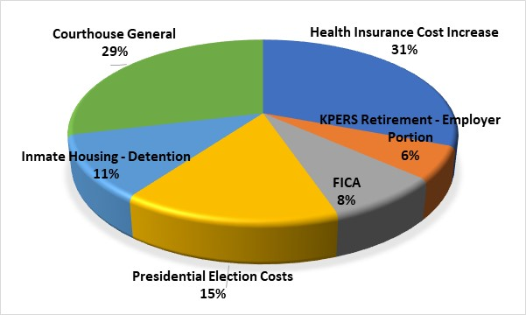

Budget Details

The proposed budget supports a slightly lower mill levy for the 2020 year. As stated in previous years. lowering the mill levy further would cut expenditures into the foreseeable future or until the state lifts the current tax lid. There were several requests to increase expenditures by supported agencies that were not able to be funded. Supported agencies as well as all county departments were held at the 2019 level with the exception of the increases mentioned previously.

This slide represents the amount of change in General Fund accounts from the estimated 2019 budged expenditures and the proposed 2020 budget. Notice the increase in election cost due to a presidential election year, increased costs in the adult detention fund for inmate medical costs, increases in Courthouse General fund for exceptional court cases, and increases in IT for increased server maintenance fees.

The following chart shows anticipated revenue for all levied funds with the exception of ad valorem tax, which is only 59% of the county’s revenue. Other revenues include grants, local sales taxes, and cash carry forward.

Levied Funds Anticipated Revenues

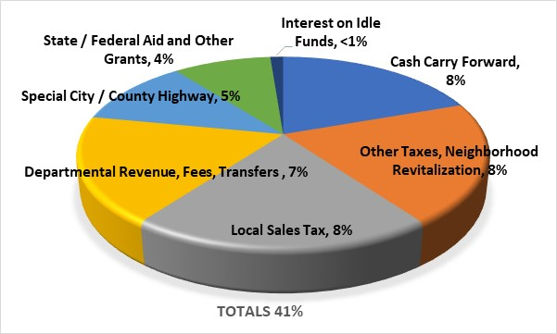

This chart shows a breakdown of planned expenditures for all levied funds in 2020: Notice 2/3 of these expenditures are attributed to public health, roads and bridges, and emergency response.

Levied Funds Planned Expenditures

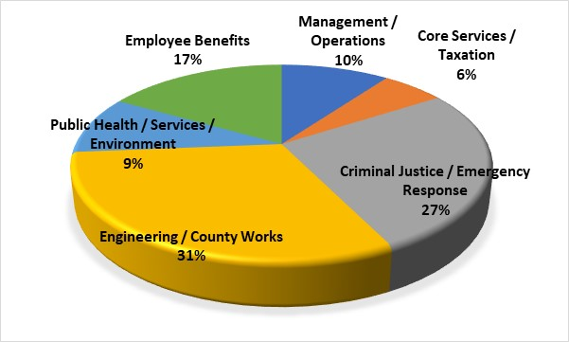

The Notice of Budget Hearing that was published July 24th provides an overview of the proposed county budget. This Notice details the actual expenses for 2018, adopted expenses for 2019, and the proposed budget for 2020. The most significant number in the Notice of Budget Hearing is the estimated mill levy of 43.641 which is slightly lower than the 2018 mill levy that funded the 2019 budget. This again is a function of the tax lid, lowering the mill levy further would limit expenditures for the foreseeable future, or until the legislators modify the tax lid. The total mill levy, 43.641, generates $12,089,420 in property tax and is equivalent to $277,023 per mill.

In summary, the 2020 budget is funded by a slightly lower mill levy, which is possible due to increased valuations.

FUTURE PLANNING

While the proposed 2020 budget included increased valuations that allowed for necessary funding of uncontrolled costs, it also allowed for a wage adjustment for better alignment with other surrounding cities and counties. The Commission and County Officials have also planned for future expenditures and budget constraints such as a potential valuation decrease in 2021, increased exceptional court case costs, aging infrastructure at the Courthouse, and updating the emergency services radio system.



SUMMARY

In summary, the 2020 budget is funded by maintaining a constant mill levy, which is possible primarily due to the Overland Pass Pipeline 10-year tax exemption expiring which increased valuation.

Fortunately, through fiscally responsible planning, the County presently has adequate cash reserves in the Capital Improvement and Equipment Replacement Accounts. By not depleting reserves to fund the proposed budget, the county remains fiscally sound and is in the position to sustain a constant mill levy while providing quality services.

I want to thank the Commissioners for their hard work on the budget as well as the elected officials, department heads, and supported agency heads for their assistance. I also want to recognize Matt Patzner, Finance Officer his contributions to the proposed budget.

