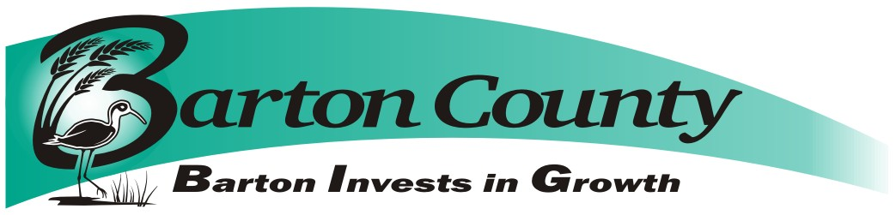
September 27, 2019

Request for Proposals (RFP)
For: Interior wall stucco repair, Barton County Courthouse
Submission deadline: 2:00 pm Wednesday, October 30, 2019

Questions about the RFP may be submitted, in written form, to:

Phil Hathcock
County Administrator
1400 Main Room 107
Great Bend KS, 67530
(620)793-1800
or emailed to phathcock@bartoncounty.org

Questions will be answered within 2 business days via email with a return reply acknowledging receipt of the email requested. Questions and answers will be shared with all bidders.

Introduction
Barton County, (Owner) invites proposals for the repair of interior stucco walls on the 4th floor of the Barton County Courthouse, 1400 Main St, Great Bend, KS as described below.
Submission Procedure
Proposals conforming to the requirements set out below must be received by Barton County via US mail or courier to Barton County Clerk, 1400 Main Street, Room 202, Great Bend KS 67530 no later than the deadline given above. Proposals must state that they are valid for a period of at least thirty (30) days from the closing deadline. Proposals must be submitted in sealed envelope and marked, Courthouse, Interior Wall Repair. Barton County reserves the right to waive irregularities and to reject any or all bids. This purchase will be sales tax exempt.

Barton County will not consider any bid not prepared and/or not submitted in accordance with the provisions hereof and may waive any informalities or reject any and all bids. Any bid may be withdrawn prior to the above scheduled time for the opening of bids or authorized postponement thereof. Any bid received after the time and date specified shall not be considered. Bids submitted after the closing date and time will be returned to the bidder unopened. No bidder may withdraw a bid within thirty (30) days after the actual date of the opening thereof.

Modification of Bids
Modifications to bids already submitted will be allowed if submitted in writing prior to the time fixed in the Request for Proposals. Modifications shall be submitted as such and shall not reveal the total amount of either the original or revised bids.
Opening, Evaluation and Contracting
Proposals will be opened by Barton County on 2 pm Wednesday October 30, 2019. All proposals satisfying the requirements of this Request for Proposals will be evaluated to establish which of the offers best fulfills the needs of Barton County. Barton County anticipates entering into a contract with the successful bidder to repair said walls. This Request for Proposals, however, does not commit Barton County to award a contract, to pay any costs incurred in the preparation of a proposal or to contract for the goods and/or services offered. Barton County reserves the right to accept or reject any or all proposals received as a result of this request, or to cancel this Request for Proposals, if it is in the best interests of Barton County to do so. The decision of Barton County shall be final.

Proposal Contents
Proposals, together with letters of transmittal, should include the bidder’s description of the equipment that would be delivered and the following information:

- The name of the person in your firm who would be the official contact person for any contractual relationship.
- Email address of contact person.
- Attached Bid Form.
- Manufacturers’ warranty specifications.
- Certificate of Insurance

PROPOSED SCOPE OF WORK:
Interior wall Repair at Barton County Courthouse
The west interior wall of the 4th floor of the Barton Courthouse has experienced water damage causing the existing stucco to delaminate in certain offices and areas. The successful bidder will be required to remove delaminated stucco, repair to match undamaged areas, and repaint entire affected offices and or areas. Interested bidders are encouraged to perform a site visit to determine the exact square footage of the area in question.
Permitting
The Vendor is solely responsible to apply, pay for and obtain all local, state, or federal permits if they are required for repair or construction of said walls.

Warranty
The Vendor must provide pricing for standard manufacturer warranty if applicable. The warranty shall include all parts and labor charges associated with warranty covered repairs.

PRICE OF PROPOSED WORK

Repair of Courthouse Walls $____________

Other, Explain

Exceptions, Explain

Company:________________________________

Submitted By:__________________________________Date:__________
Principle or Authorized Agent

By signature above, bidder agrees that pricing submitted is all inclusive of products as described in bid documents.

BARTON COUNTY RESERVES THE RIGHT TO ACCEPT OR REJECT ANY OR ALL BIDS.

