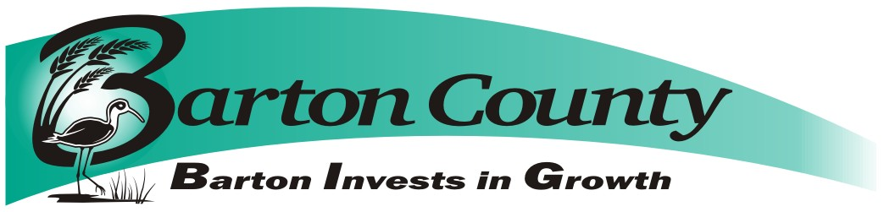
April 15, 2021

Request for Proposals (RFP)
For: Radio Tower painting
Submission deadline: 2:00 pm Friday, May 28, 2021

Questions about the RFP may be submitted, in written form, to:

Dena Popp
911 Director
1300 Stone St
Great Bend KS, 67530
(620)793-1920
Fax (620)792-3222
or emailed to dpopp@bartoncounty.org

Questions will be answered within 2 business days via email with a return reply acknowledging receipt of the email requested. Questions and answers will be shared with all bidders.

Introduction

Barton County Communications 911, (Owner) invites proposals for painting of an approximately 330 foot radio tower, located just east of Susank Kansas on NE 190 Rd. Bidders are encouraged to visit the tower site prior to submitting proposals.
Submission Procedure

Proposals conforming to the requirements set out below must be received by Barton County via US mail or courier to Barton County Clerk, 1400 Main Street, Room 202, Great Bend KS 67530 no later than the deadline given above. Proposals must state that they are valid for a period of at least ninety (90) days from the closing deadline. Proposals must be submitted in sealed envelope and marked, Radio Tower Painting (Susank), Barton County reserves the right to waive irregularities and to reject any or all bids. This purchase will be sales tax exempt.

Barton County will not consider any bid not prepared and/or not submitted in accordance with the provisions hereof and may waive any informalities or reject any and all bids. Any bid may be withdrawn prior to the above scheduled time for the opening of bids or authorized postponement thereof. Any bid received after the time and date specified shall not be considered. Bids submitted after the closing date and time will be returned to the bidder unopened. No bidder may withdraw a bid within sixty (60) days after the actual date of the opening thereof.

Modification of Bids

Modifications to bids already submitted will be allowed if submitted in writing prior to the time fixed in the Request for Proposals. Modifications shall be submitted as such and shall not reveal the total amount of either the original or revised bids.

Opening, Evaluation and Contracting

Proposals will be opened by Barton County on 2 pm Friday, May 28, 2021, or anytime thereafter. All proposals satisfying the requirements of this Request for Proposals will be evaluated to establish which of the offers best fulfills the needs of Barton County. Barton County anticipates entering into a contract with the successful bidder to purchase said services. This Request for Proposals, however, does not commit Barton County to award a contract, to pay any costs incurred in the preparation of a proposal or to contract for the goods and/or services offered. Barton County reserves the right to accept or reject any or all proposals received as a result of this request, or to cancel this Request for Proposals, if it is in the best interests of Barton County to do so. The decision of Barton County shall be final. Payment to be made to the contractor upon completion of the services and inspection by Barton County personnel. Successful bidder will accept responsibility for any damage incurred to any and all equipment, cables, or lighting during the painting process.

Proposal Contents

Proposals, together with letters of transmittal, should include the bidder’s description of the equipment that would be delivered and the following information:

- The name of the person in your firm who would be the official contact person for any contractual relationship.
- Email address of contact person.
- Attached Bid Form.
- Paint manufacturers’ specifications detailing compliance with specifications in “Specifications” section of this RFP.
- Certificate of Insurance for the bidder
- Affidavit of exempt status under worker’s compensation act, should bidder not maintain workers compensation insurance.

Specifications
Successful bidder shall paint the 330-foot radio tower at Susank, Ks located at 46 NE 190 Rd, Hoisington KS 67544.
Specifications as follows:
1.) Remove any peeling existing paint, remove any rust associated with areas of peeled paint.
2.) Paint above referenced tower in accordance to Federal Standard FED-STD-595 using exterior Solvent-Borne Alkyd-Based Paint, per FAA Advisory Circular 47 CFR §§ 17.21-17.58.
3.) Tower paint must meet Federal Standard 595 color #17875 for the white and color #12197 for the aviation orange.
4.) Site must be cleaned and debris free when project is complete.
Schedule
Painting of tower to be completed by October 1, 2021.
Permitting

The vendor is solely responsible to apply, pay for and obtain all permits if they are required for the painting of this tower.

PRICE OF PROPOSED TOWER PAINTING

Lump Sum $____________

Other, Explain

Exceptions, Explain

Company:________________________________

Submitted By:__________________________________Date:__________
Principle or Authorized Agent

By signature above, bidder agrees that pricing submitted is all inclusive of work as described in bid documents.

BARTON COUNTY RESERVES THE RIGHT TO ACCEPT OR REJECT ANY OR ALL BIDS.

